**VIA Club**

**Students:**

**Vaclav Dvorak, 285049**

**Alejandra Leticia Gonzalez**

**Roldan,285133**

**Ramanpreet Singh, 285506**

**Jose Martinez, 285046**

**Supervisor:**

**Mona Wendel Andersen**

**Alan Rune Henriksen**

**Bachelor of Engineering in Information &**

**Communication Technology**

**Summer 2019**

**28.2.2019**

Version: 19.3.2019

**Table of content**

1 Background description 1

2 Definition of purpose 2

3 Problem Statement 3

4 Delimitation 4

5 Choice of models and methods 5

6 Time schedule 8

7 Risk assessment 9

8 Sources of Information 11

Appendices (including Group Contract)

# Background description

Sport has lately become more about business and good sport manager needs a proper Sport Management System in a form of a computer application in order to be successful (Ramesh, 2016). Representative web site as a tool of attracting new fans is a welcome accesory(View, 2016).

VIA Club has been an athletics club with long history but for quite some time it has been exclusively outdoor football team with a veteran sport manager leading the team on his own without using any Sport Management System. As a result, to this day all tasks are being handled manually. In general, that means creating, editing and keeping the players and their attributes, the squad lists, the match lists manually.

To be more specific, the manager needs to write down the squad of players, both start and substitutes players, for upcoming match just on a paper. That can easily result in lost of the paper and therefor all the work. In order to set the squad properly, the manager needs to keep all related player data in his head. That can easily result in forgetting the data or missing some interesting point of view on such a data. On top of that, editing the data, that has been put on the paper once, has proven ineffective and chaotic, especially since it is useful to create even future squad lists for future games at the same time. Since VIA Club plays several leagues at the same time, the manager needs to keep in mind what type of match is upcoming, because the type of match can change the rules in terms of how many substitute players can be on the bench.

Similar problem occurs while keeping list of players and their data such as if a player has been injured. As before, it is all stored on a piece of paper, which results in same problems as mentioned above.

There is also a separate problem in a form of outdated team webpage, which is not representable anymore and there is a fear that it is not attractive for potential new fans.

# Definition of purpose

The purpose is to develop a Sport Management System in a form of a computer application that would be used by VIA Club manager in order to efficiently create, keep and edit: player lists, squad lists and match lists based on players and matches data and to create representative web site.

# Problem Statement

**Overall problem**: Switching from manually keeping data on a paper to Sport Management System in a form of computer application that can create, edit and store data of players, matches and squads based on the VIA Club manager requirements, which include keeping data and specific relations between players, matches and squads. Additional task is to create a website that would be attractive for potential new fans.

**Subproblems:**

* What data/information exactly does the VIA Club manager need to work with in terms of players, matches, squads?
* What procedures and workflows does the manager need to follow in order to create, update and store data of players, matches, squads?
* What are the connections/relations between players, squads, matches?
* What should the website contain?

# Delimitation

Sport Management System and Web page for VIA Club are delimited by following:

* Sport Management System will not be able to store the data in database
* Sport Management System will be written in Java language
* System will serve to VIA Club and his manager only
* Web page will not be able to work properly on all devices

# Choice of models and methods

|  |  |  |  |  |  |
| --- | --- | --- | --- | --- | --- |
| **What:** | **Why:** | **Which level of outcome is expected:** | **Which methods/models:** | **Responsible team member:** | **Estimated time:** |
| What data/information exactly does the VIA Club manager need to work with in terms of players, matches, squads? | It needs to be clear, what information the manager needs to know about squads, players, matches. | Complete understanding of what data the manager needs to work with. | Use Case (summarize based on interview with the manager). Additional interview might be needed. | Vaclav Dvorak (285049) | 6 hours |
| What procedures and workflows does the manager need to follow in order to create, update and store data of players, matches, squads? | It needs to be clear what order of actions the manager follows while working with the squads, matches and lists of players in order to understand how to create/edit and store players, matchers and squad data properly. | Complete understanding of what data the manager needs to see and work with in the application at any given moment | Activity diagram based on  Interview with the manager. Additional interview might be needed. | Alejandra Roldan (285133) | 8 hours |
| What are the connections/relations between players, squads, matches? | It needs to be clear what the relations between players, squads and matches are in order to work with them properly | Complete understanding of how matches/players/squads data are connected | Use Case (summarize based on interview with the manager). Additional interview might be needed. | Jose  Martinez  (285046) | 8 Hours |
| What should the website contain? | It needs to be clear what content and design should the web page have. | Based on sketches and interview with the manager. | Website Blueprints/sketches. Additional interview might be needed. | Ramanpreet Singh  (285049) | 8 Hours |

# Time schedule

Time schedule is described on chart below.

Activity:

1. *Project Description-1st Draft* --> document should be ready for the *First Hand In*, expected load of work in hours=64
2. *Group meetings* -->group meetings are expected every week during the whole project, Process and Project report are being processed, expected load of work in hours=76
3. *Project Description-1st Revision* --> document is being updated and should be ready for the *Peer Review*, expected load of work in hours=8
4. *Project Description-2nd Revision* --> document is being updated and should be ready for the *Final Hand In*, expected load of work in hours=8
5. *Requirements* --> requirements are being gathered and processed as a final input for *Analysis and Design*, expected load of work in hours=20
6. *Analysis and Design* --> future system behavior is described as final input for *Development*, expected load of work in hours=82
7. *Development* --> system coding, expected load of work in hours=272
8. *Testing* --> system Testing, expected load of work in hours=20

**Total estimated time=550**

**Chart1-Time Schedule**

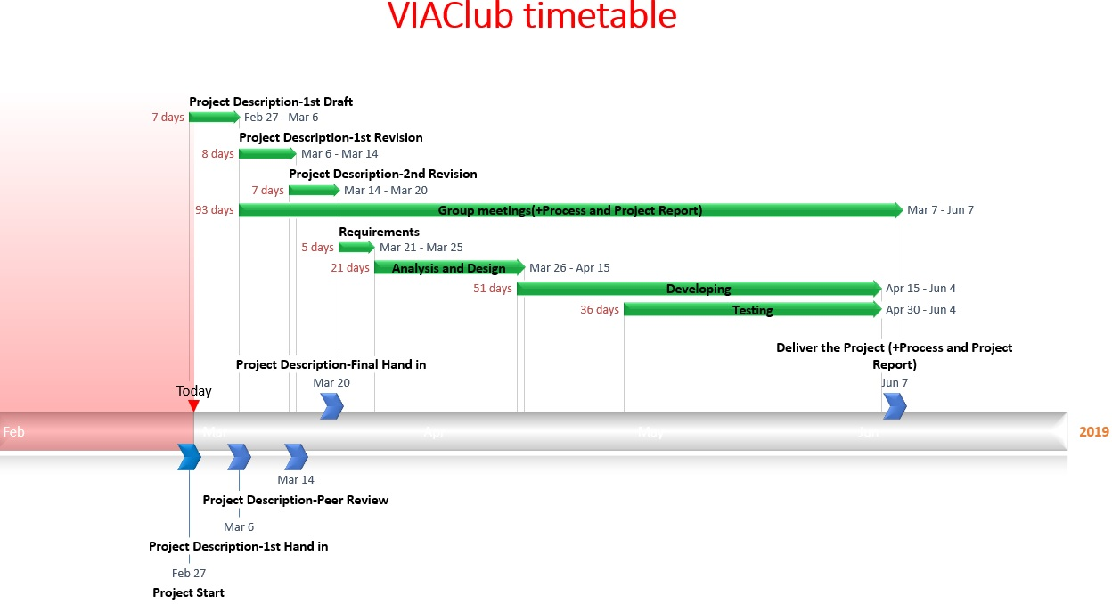

# Risk assessment

|  |  |  |  |  |  |  |  |
| --- | --- | --- | --- | --- | --- | --- | --- |
| Risks | Description | LikelihoodScale:1-5  5 = high risk | Severity  Scale:1-5  5 = high risk | Product of likelihood and severity | Risk mitigation  e.g. Preventive & Responsive actions | Identifiers | Responsible |
| Risk 1 | Possibly insufficient time for members with a job | 2 | 2 | 4 | Home-office, which would save some time | Excuses, insufficient performance | Alejandra Leticia Gonzalez Roldan |
| Risk 2 | Possibly insufficient time for members with kids | 3 | 3 | 9 | Members with children can work online without the need to attend every group meeting | Excuses, insufficient performance | Jose Martinez,  Alejandra Leticia Gonzalez Roldan |
| Risk 3 | Insufficient time during exam period | 4 | 4 | 16 | This problem could be handled by proper time management | Exam period | Jose Martinez,  Alejandra Leticia Gonzalez Roldan, Vaclav Dvorak, Ramanpreet Singh |

# Sources of Information

Duckett, J., 2011. *HTML&CSS design and build websites*, Indianapolis: John Wiley & Sons, Inc.

Duckett, J., Ruppert, G., Moore, J., 2014. *JAVASCRIPT & JQUERY Interactive Front-End Web Development,* Indianapolis: John Wiley & Sons, Inc.

Gaddis, T., 2015. *Starting Out with Java: Early Objects*, 5th edition. Harlow: Pearson.

International Journal of Physical Education, Sports and Health, 2016. *Role of information technology in enhancing sports performance*. [online] Available at: < [http://www.kheljournal.com/archives/2016/vol3issue5/PartE/3-5-19-453.pdf> [Accessed](http://www.kheljournal.com/archives/2016/vol3issue5/PartE/3-5-19-453.pdf%3e%20%5bAccessed) 1 March 2019].

LaGrone, B., 2013. *HTML5 and CSS3 Responsive Web Design Cookbook*. Birmingham:Packt Publishing Ltd.

ThemeBoy, 2016. *10 Features All Sports Websites Need to Make an Impact*. [online] Available at: <https://www.themeboy.com/blog/10-features-sports-websites-need-make-impact/> [Accessed 1 March 2019].

**Appendices**

-Group Contract